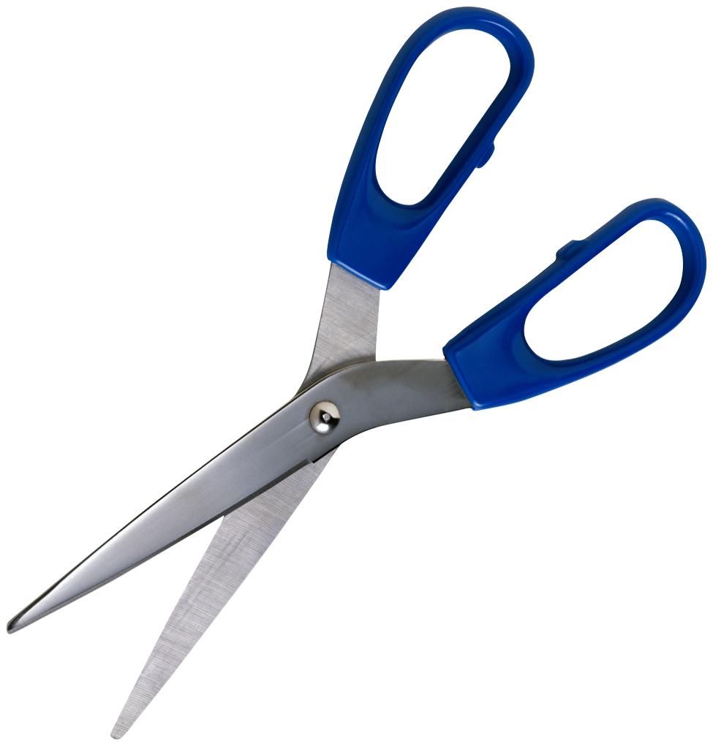

www.sunshinecoastukulelemasters.com

Payment can be made at a club meeting by cash, cheque, card or bank transfer. Please note that membership cards must be collected at a club meeting. If you wish to have your membership card posted there will be a cost of $2 for postage.

**Membership Paid $25. Date**……………………………………

Thank you for joining Sunshine Coast Ukulele Masters Inc.

We are an incorporated club, which means we are not profit organisation. If you wish to read our Constitution, please send us an email. We generally hold two club meetings each month and all details are on our website including meeting dates. As a member you will receive a newsletter prior to meetings about upcoming meetings, Zoom details, new songs, and other

info. Workshops are held regularly and are free to all members.

**PAYMENT RECEIPT**

**Admin use only**.

Date Paid………………………………………………… Amount Paid……………………………………..

Amount…………………………………………………… Date Processed………………………………….

Paid by: Bank Transfer/Cash/Card/Cheque

**Sunshine Coast Ukulele Masters Inc.**

**BSB: 124 081 Account: 22270731**

**Please email copy of payment to**

**scummeetings@gmail.com**

**PLEASE COMPLETE ALL YOUR DETAILS (it is important that you print clearly)**

First name Family name

Email

Address

Phone

Date Signature

Annual fee: $25

Meeting attendance: $2

Children 10 & under: Free

Annual memberships are due in January and are valid to the following December.

Sunshine Coast Ukulele Masters Inc.

**2024 Membership Form**